Theme: Flipkart Review Scrapper

Submitted By: Aakash Mittal (21MCI1242)

**INTRODUCTION**

If we want to do shopping from online platform then what we do, we search the website and search the products in search bar. Prior to buying products we first see the reviews of each product in most of the time checks the rating , read the comments , number of likes and dislikes for each product. And mostly these reviews are thousands in number which takes lot of time to read and understand about the product.

So we can say buying a product now-a-days totally depends upon rating provided by the customers (users of that particular products).

**Theme:** Review Scrapping: Flipkart

(Scrapping reviews from Flipkart website according to the product search)

**Aim/Objective**

In this project we scrap the reviews of the product from flipkart sales website. The Aim of the project is to get the most preferred model of the products completely depends upon the reviews of the customers. So instead of searching and viewing reviews one by one we can scrap all reviews of that particular product at one place.

**Technologies Used**

* Python Language
* HTML
* CSS
* API using FLASK
* Database: SQL

**Front End:**

* Step1: Click on the link :

<https://flipkart-review-scrapper0299.herokuapp.com/>

* Now to log in the Web App (Review Scrapper Tool) Enter ‘Username’ and ‘Password’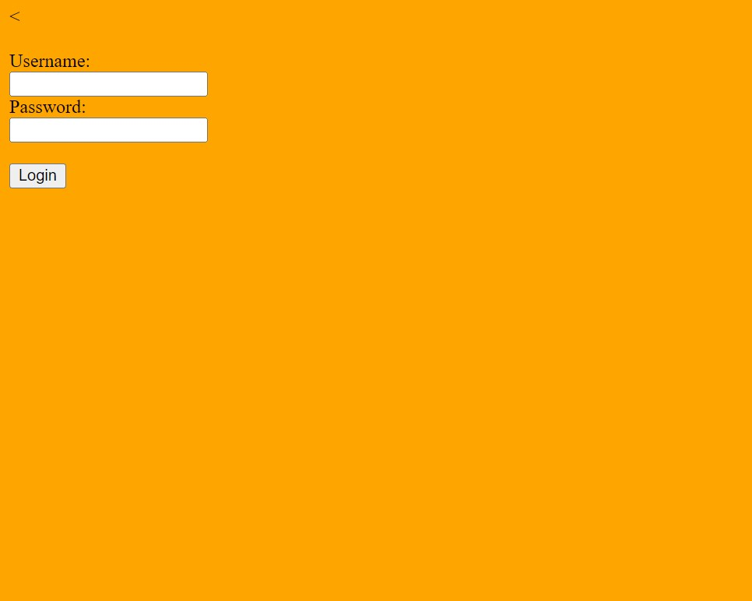

3 username and passwords are stored inside the database

database={'Aakash':'1234','Dev':'4321','Harry':'@1234'}

, if typed credentials matched with stored credentials then user is able to login to the App.

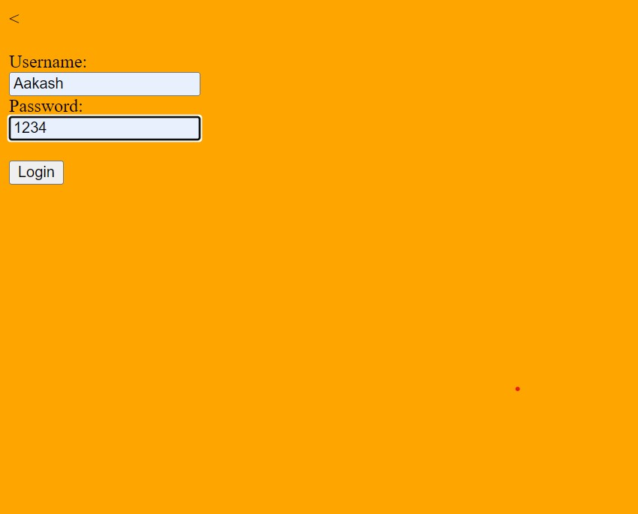

And after login user is able to access ‘Search’ Page.



Else there is a pop up that ‘Invalid User’.

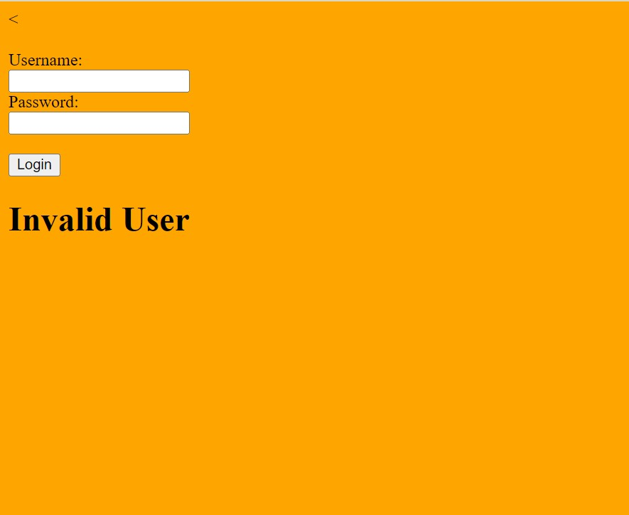

* Now on coming to the Search Page. User is able to search the product for scrapping all the reviews on one single place.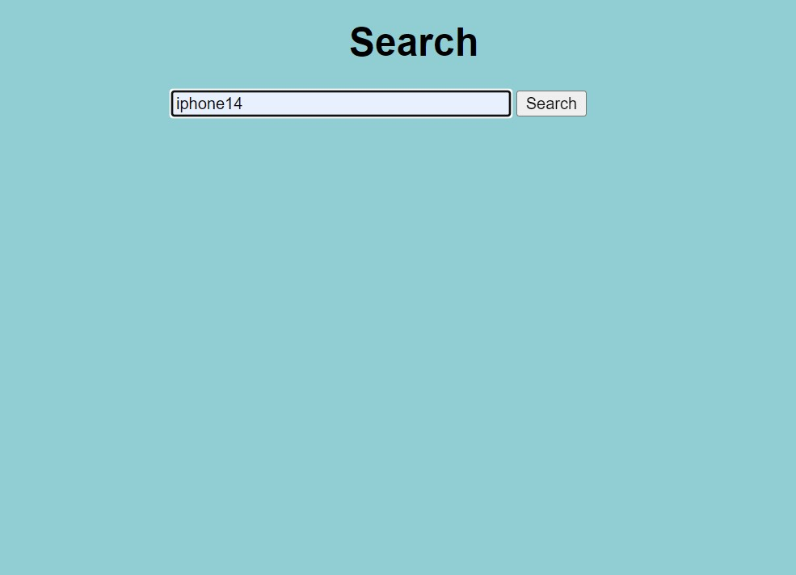

On clicking Search button it shows the result.

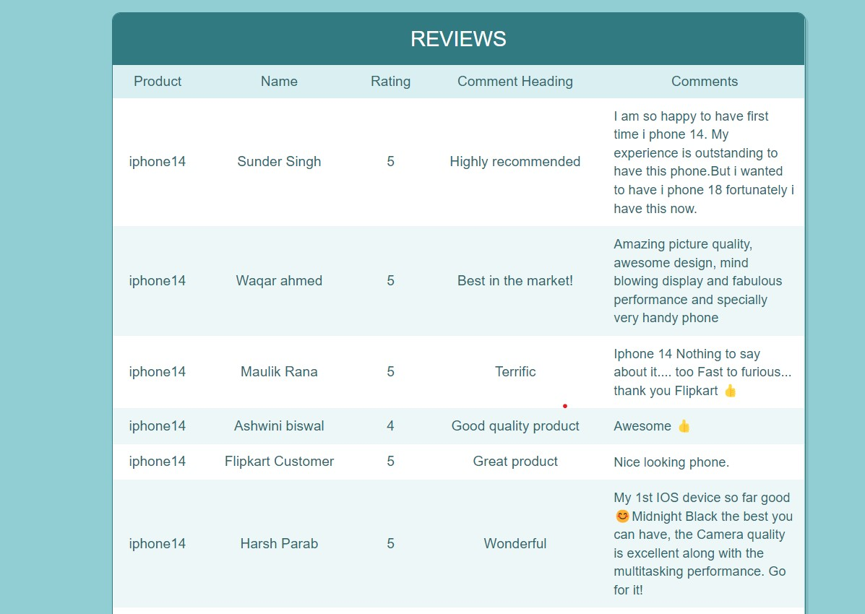

**Github Repository Link:** [**click here**](https://github.com/aakash-OM/Reviews_Scrapper_from_flipkart)